**CRM Web application**

**1.0 INTRODUCTION**

This project called CRM Web Application addresses the implementation of Customer Relationship Management (CRM) in **Donegal Insurance Group** which spans more than 125 years in the insurance business. Thus, we used our many years’ specialized addressing regional and international solutions for customer relationship management.

For this company, we focus on strategies used in sales management with reference to the standards of customer service and the models used in customer relationship management. Our aim is to apply the benefits resulting from the application of new technologies to the new opportunities and the need for flexibility in the relationship with customers for this company.

The rising expectations of customers have forced the insurance sector to introduce more and more new

customer relationship management initiatives as it has got a serious impact on the sale of the insurance

products, while the technological advances and decreasing costs of technology have reduced barriers to

adopting IT based CRM initiatives. As the profitability of the insurance sector is mainly depend on the services

it offers and on meeting the customer demand on a regular basis, this suggests that a good CRM initiative must

be the foundation of the insurance sector. The major burden the industry faces is obtaining and keeping clients.

This is due to the fact that it has become increasingly difficult for this particular sector to gain profits while

curtailing costs.

**2.0 THOUGHT OF DESIGN**

A satisfied customer stays true to our company, purchases other insurance products as well, sends off

favorable messages for the company's image and the products, pays less attention to competing brands and to

their advertising and it is less sensitive to price, implying a lower cost of service than new customers because

transactions are already a matter of routine. Due to the extended requirements gathering way in the insurance market in the United States, it is necessary to develop American standard

after-sales service. The quality of services offered in the field of insurance is closely linked to the way

databases existing in the insurance companies are managed.

In circumstances where we have a better performing CRM system recording and managing insurance policies,

we can develop specific applications, that are necessary in the internal analysis of each department taking into

consideration its activity and can be used to analyze the volume of the gross written premiums, the amount of

compensations paid, the continuity and age of insurance - per customer, per business line (property, auto,

liability, etc.) per branch / inspector, per collaborator etc. The utilities of applications developed for the

customer portfolio underlies the development of the customer care activities. Among these we mention:

• Customer notification services on payment deadlines and renewal of insurance policies;

• Providing facilities or bonuses according to the customer’s contract length and damage rate;

• Services to inform customers about new products, promotional offers etc.

A particularly important benefit for the company, resulting from these specific applications, is the possibility

of identifying profitable customers considered according into business lines, in order to make them loyal on the

long run. Identifying and retaining customers that register a damage rate in the **Donegal Insurance**

**Group** segment is an important prerequisite for making this segment profitable.

**3.0 BENEFITS OF CRM IMPLEMENTATION**

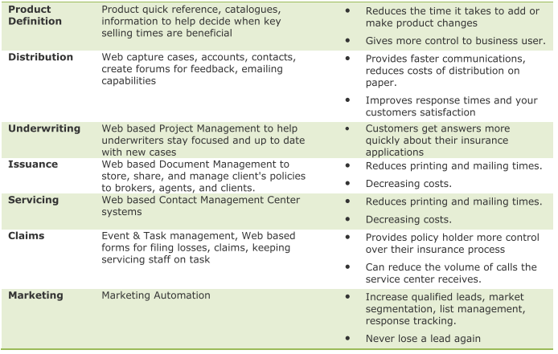

**4.0 THE FLOW OF DEVELOPMENT**

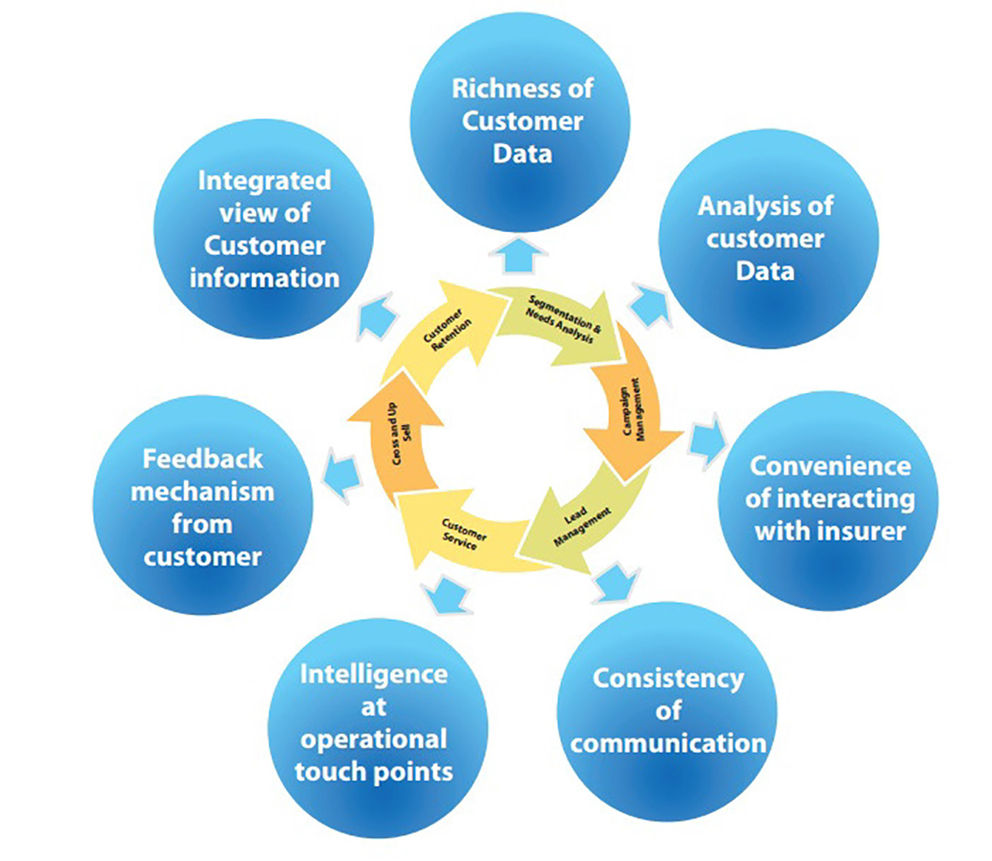

**5.0 THE PROCESS OF IMPLEMENTING OUR CRM**

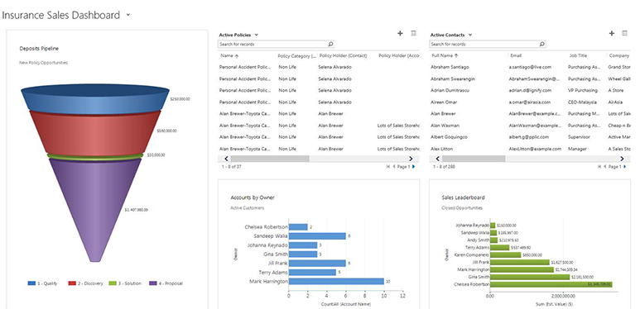

The new CRM which we design will provides comprehensive insurance functionality including New Policy Pipeline, Sales Goals Vs. Actuals, Claims Management and Activity & Task Management.

**5.1 Sales Pipeline Management for New Policies**

* Track sales pipeline by producer and insurance carrier
* Track won/loss ratio and ability to win against competitors
* Setup Sales Targets for producers and track progress against sales targets

**5.2 Robust Sales Process to Improve Producer Effectiveness and Agent Productivity**

* Insurance process manager automatically creates activities for the producer that guides them through the process to increase sales effectiveness.
* Automatic alerts for sales managers when agents do not complete tasks assigned to them
* Generation of quotes and responses to RFP with accurate pricing for the policies to generate new clients
* Up-sell, cross-sell other insurance products to existing clients
* Develop appropriate, targeted marketing campaigns to different client segments

Improve producer productivity by providing automated activities to be completed based on the state a new policy is in.

* 1. **Extensive Life and Non-Life Insurance Policy Management**
* Empower customer service representatives and insurance agents by providing information at their fingertips on active policies, upcoming renewals and policy premiums
* Support for both life and non-life (Auto, Theft, Accident, Health, etc.) policies
* Create policies from carriers through import or Integration with Carriers
* View policy exclusions on a policy
* Record deductibles, premiums and coverage on a policy.
* Renewal of policies with ability to carry over deductibles, premiums from one period to another.
  1. **Improve Customer Satisfaction**
* Agents get a complete view of a customer relationship including all scheduled and past interactions, such as phone calls, emails, meetings and other activities.
* Customer service representatives and producers can view Active and Expired Policies for a customer with deductibles, premiums and expiration / renewal dates.
* Create and support cases by policy, client, producer or contact
* Knowledge base with suggestions on the articles that is likely to solve the issue
* Store electronic documents including policies on the client and policy record

**5.5 Record and Manage Claims**

* Differentiate yourself from other insurance brokerages by recording claims from customers, and track claim from claim report to final status of a claim.
* Record payout dates of any payments made by the insurer
* Ability to see claim history at any point for your customer base

**5.6 Marketing Campaigns and Lead Management**

* Setup multiple marketing campaigns with ability to create planning activities and campaign budget
* Distribute campaign activity e.g. phone calls, meetings to salespersons
* Log campaign responses with codes with ability to promote a response to an opportunity
* Measure effectiveness and ROI of campaigns and compare budget to actuals
* Automated Email campaigns for policy renewals, birthday and other events
* Tie promotions and products to campaigns measure revenue generated from campaigns
* Measure campaign effectiveness by channel
* Track Leads by channel
* Qualify or disqualify leads and promote to opportunities
* Track completion of campaign activities and lead qualification activities by owner.

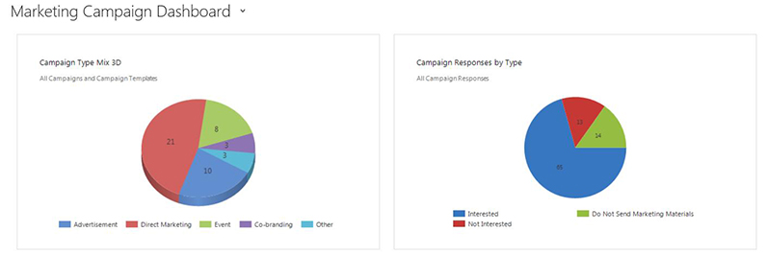

**5.7 Comprehensive Reporting**

* Ability to modify existing dashboards and create new dashboards
* Ability to build reports very easily through a report wizard
* Export reports to Excel, Word, PDF
* Schedule reports to be automatically emailed
* On-demand reporting for agent and broker productivity, new business pipeline, customer loyalty
* Reporting on sales goals vs. targets for agents, producers and **brokers.**

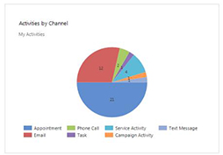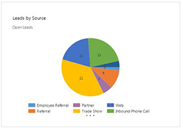

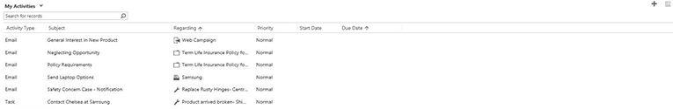

Rich reporting and Dash boarding capability allow sales managers and executives get to information very quickly. Additionally, operational dashboards for salespersons and administrators provide information about their individual goals. Ticklers and alerts ensure team members stay focused on completing their tasks.

**6.0 TECHNOLOGIES AND ENVIRONMENTS APPLIED**

Java8, Spring Boot 2.2, Spring Security 5.2, HTML5, CSS3, JavaScript, React 16.7, Jest 24.x, Enzyme 3.x, Bootstrap 4, MySQL 8, Hibernate 5.0, ORM 4.3, Docker, Git, JIRA, Microservices, RESTful Web Services, JSON, Maven 3.6.3, Tomcat 9.0, AWS EC2, S3, RDS, IAM, JMS 2.0, Apache Kafka 2.4, Apache RabbitMQ 3.7, Apache Jenkins 2.2, JUnit 5.6, Mockito 3.2, etc.

**7.0 RESOURCE CODE ABOUT THIS PROJECT**

IT IS ATTACHED IN THE OTHER FOLDER.